Extended Project Qualification

Thomas William Le Huray

0933

Elizabeth College

67104

For my EPQ I am designing and manufacturing a robotic arm. I chose this as my artefact as I am interested in a career in robotics. The design and manufacture of the arm would also draw on skills that I have learnt in my Maths, Physics and Computer Science A Levels. I decided that an arm that can lift less than 0.8 kilograms would be sufficient for the applications that I might use it for, such as removing prints from a 3D printer or experimenting with different methods in control software.

I began by researching how previous robotic arms have been built mainly focussing on how modern industrial arms have been designed, for example Axis 4 through to 6. I was heavily inspired by the inner workings of the Vika-350 Industrial Robotic arm (Kesici, 2017). I also looked at open-source robotic arms such as the Annin AR4, designed by Chris Annin (Annin, n.d.). A lot of my research was into reducers, which are gearboxes designed to increase the torque of a motor. The most common type of reducer in robotic arm applications is the harmonic drive, named after the German corporation Harmonic Drive SE, the main supplier of harmonic drives in the industry (Harmonic Drive, n.d.).

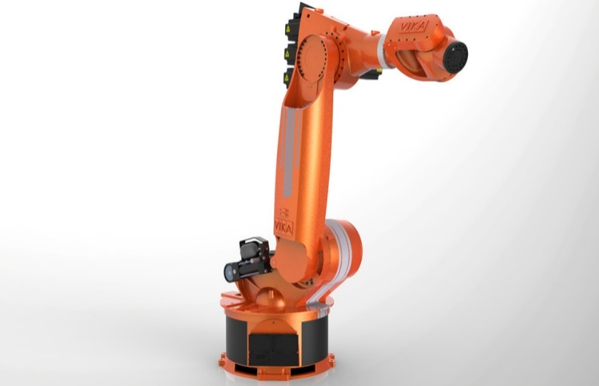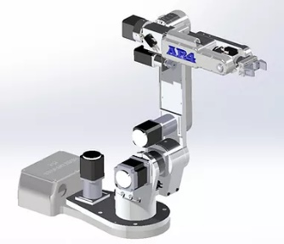

Figure 1 Above left Vika-350 Industrial Robotic arm (Kesici, 2017). Above right Annin AR4 Robotic Arm (Annin, n.d.).

When I was designing the arm, I went through four iterations of the overall design. Mk1 to Mk3 all used the same metal arm pieces I had recycled from a scrapped screen soldering machine at Offshore Electronics where I had done my work experience placement. The design for Mk1 used many bespoke components for each joint increasing the complexity of the design. I soon realised that it was too complex to manufacture on a 3d Printer.

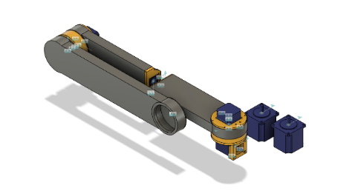

Figure 2 Mk1 Main Assembly CAD Design

In the design for Mk2 I used an increased number of shared components, and the design was lighter than the previous version. I spent a lot of time designing a harmonic drive reducer, which are also called Strain Wave reducers. Strain wave reducers work by rotating an elliptical plane that forces a flexible gear, called the flexspline, to mesh with a fixed internal gear. In an industry standard design, the flexspline is attached to the output of the reducer, however due to the nature of 3D printed materials this is not possible as the flexspline will crack and fracture. In a 3D printed design another non-flexible internal gear is placed on top and used as the output, this design is inspired by the work of both 3D Printed Life (3DPrintedLife, 2021) and Levi Janssen (Janssen, 2019). This iteration of the arm was still too heavy due to the weight of the shared components of the arm, which led to Mk3.

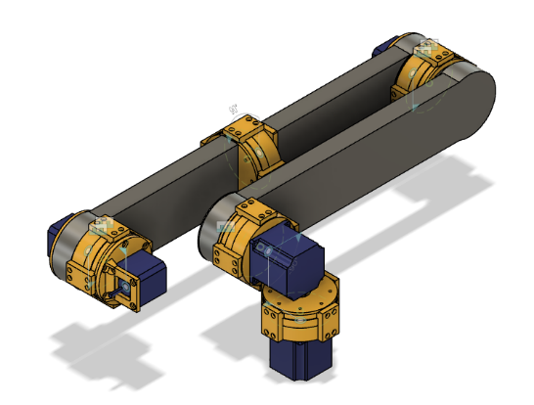

Figure 4 Mk2 Main Assembly CAD Design



Figure 3 Diagram showing a Harmonic Drive interior

When designing Mk3 I further increased the number of shared components and further reduced the weight, however the drives I had designed for the lower axis were too weak to lift the arm when testing the design. It quickly became apparent that the metal arm was going to be too heavy for the 3D printed reducers and the motors that I had to be able to move.

Figure 5 Above left shows Isometric sketches of Mk3 before CAD. Above right is the main reducer of Mk3

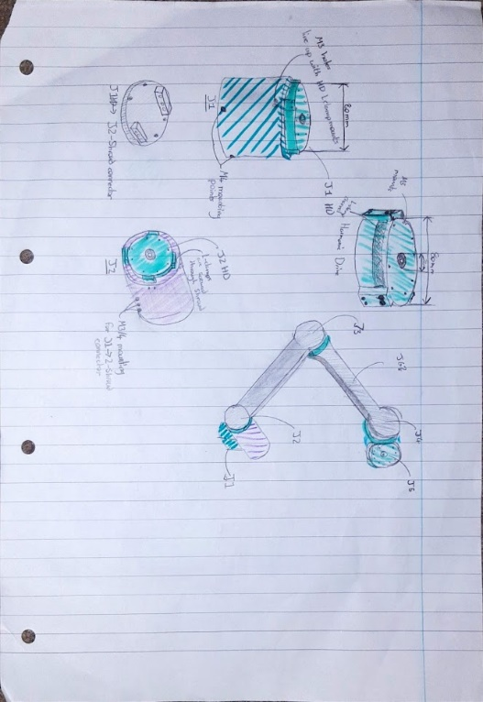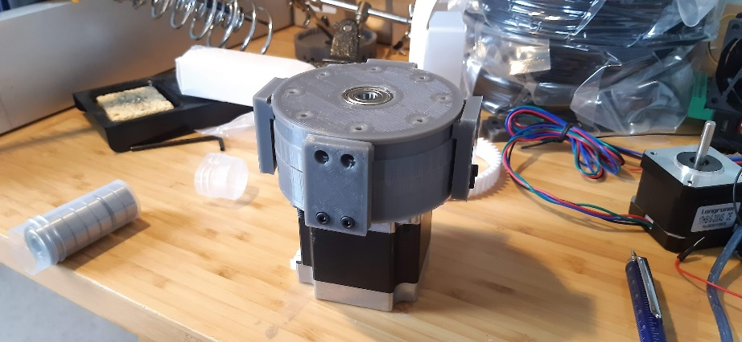

This led me to Mk4, the final design of which took a lot longer to design than the previous iterations as I had to design the whole arm from scratch for this version. Mk4.1 had various flaws, it was too big, cumbersome and some parts didn’t work as intended. Mk4.2 improved upon these flaws I managed to reduce the size by 100mm and fixed issues where parts didn’t work correctly. Mk4.2 is the culmination of the whole project, with each component being well thought out from my experience with the previous versions.

Figure Mk4 CAD Assembly

Programming the arm was complicated, I couldn’t start the programming of the control software fully without the design of the arm being completed, components would sometimes just not seem to work when inputs were given. Through my research into how to control the stepper motors I found the Accel Stepper library for Arduino (McCauley, 2020), this software library allowed me to control the stepper motors in a convenient way. To tell the Arduino which motor to control I planned to develop a system that read commands from the serial input. This system would take the axis to control, the number of steps that the motor was making, and the direction of the steps. The Arduino microcontroller is programmed in C++ then would be fed commands via a python script running on a Raspberry Pi. This would allow me to have a remote access point to the arm where I would be able to control it from.

When it came to manufacturing the arm there were difficulties throughout the process. Originally, I planned to print the whole thing on the PrintRite Colido 2.0 Plus 3D printer, however as I began testing components for Mk3 the printer stopped functioning as intended and was messing up prints. With this printer being an old printer, I searched for a replacement printer online. I landed on the Voxel lab Aquila X2 printer, an Ender 3 clone with a few more functions. Setting up the printer was a breeze, and it printed fine for all of axis 4, 5 and 6 of Mk4.1. Then the printer began clogging due to the heat break warming up too much causing plastic to melt in the worst spot possible. This led to me disassembling the printer repeatedly with no avail on getting it to run again. In the end due to a tight timeline and the deadline drawing near I focussed on improving the CAD design to a functional model.

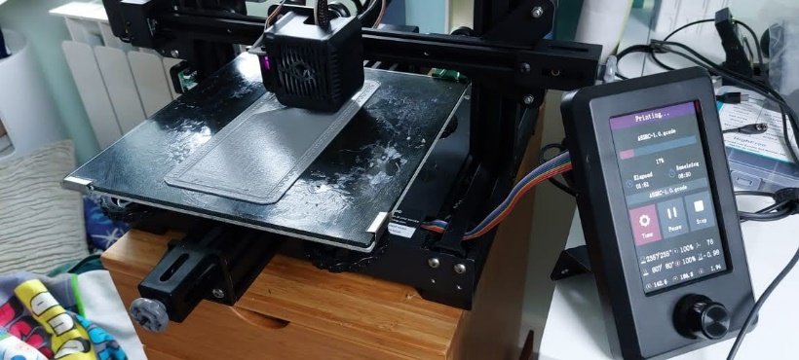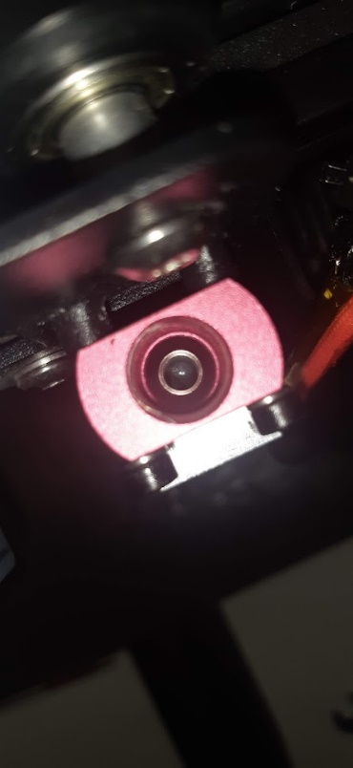

Figure Above left shows the clogged heat break through the heatsink. Above right shows the printer whilst it was working printing part of Mk4.1.

Overall, the project was mostly a success however one major flaw was the planning. I originally planned for the whole project to take around 210 days, in the end it took me 500 days. I overshot my estimated timeline by 138%. This drastic overshoot was mostly down to poor planning, with things such as not considering when I had exams, when holidays were, and generally not being able to work on the project. I think if I had been more pessimistic with my timelines, they would be far more accurate and reliable. The result of the project, Mk4.2, is a well thought out design built on the failures and shortcomings of the previous versions in addition to my improved skills surrounding CAD and 3D printing.

Figure Gantt Chart showing both my planned timeline and the actual timeline

# Works Cited

3DPrintedLife, 2021. *Integrating my Harmonic Drive - 3D Printed 6-Axis Robot Arm.* [Online]   
Available at: https://www.youtube.com/watch?v=2CdDL6JARkU  
[Accessed 11 February 2022].

3DPrintedLife, 2021. *My 3D Printed Harmonic Drive Performs Surprisingly Well!.* [Online]   
Available at: https://www.youtube.com/watch?v=Emvo3bLT-Z4  
[Accessed 4 May 2021]. Evaluation: A balanced viewpoint that explains in depth how he got from his first design to his final iteration clearly. He keeps the process concise and to the point covering all stages of the design and prototyping process.

Annin, C., n.d. *Annin Robotics.* [Online]   
Available at: https://www.anninrobotics.com/  
[Accessed 18 January 2021]. Evaluation: Fairly biased towards his own design, but still fairly credible. It was useful in finding out h0w others had developed their own designs.

Anon., 2021. *Cycloidal Drive.* [Online]   
Available at: https://en.wikipedia.org/wiki/Cycloidal_drive  
[Accessed 25 March 2022]. Evaluation: Well sourced and an unbaised view, it was a useful to find out how a cycloidal disk worked in a concise manner however it was less clear and more technically aimed at than other explanations of a cycloidal drive.

Anon., 2022. *Strain Wave Gearing.* [Online]   
Available at: https://en.wikipedia.org/wiki/Strain_wave_gearing  
[Accessed 24 January 2022]. Evaluation: Well sourced and an unbaised view, it was a useful to find out how a strain wave gearing worked and the history of the gearing in a concise manner however there were other sources that were clearer at explaining how it worked.

Anon., n.d. *17HS4401S Motor Datasheet pdf - Stepper Motor. Equivalent, Catalog.* [Online]   
Available at: https://datasheetspdf.com/pdf/1310364/Handson/17HS4401S/1  
[Accessed 23 April 2022].

Anon., n.d. *Arduino - Limit Switch | Arduino Tutorial.* [Online]   
Available at: https://arduinogetstarted.com/tutorials/arduino-limit-switch  
[Accessed 22 April 2022].

Anon., n.d. *Convert N-m to kg-m - Conversion of Measurement Units.* [Online]   
Available at: https://www.convertunits.com/from/N-m/to/kg-m  
[Accessed 24 September 2021].

Anon., n.d. *Nema 17 Datasheet | Nema 17 Bipolar 45Ncm (64oz.in) 2A 42x42x40mm.* [Online]   
Available at: https://www.omc-stepperonline.com/nema-17-bipolar-45ncm-64oz-in-2a-42x42x40mm-4-wires-w-1m-cable-and-connector.html?search=17HS16-2004  
[Accessed 18 February 2021].

Anon., n.d. *Planetary Gear Ratio Calculations.* [Online]   
Available at: https://woodgears.ca/gear/planetary.html  
[Accessed 18 April 2022].

Anon., n.d. *Short introduction — pySerial 3.4 documentation.* [Online]   
Available at: https://pyserial.readthedocs.io/en/latest/shortintro.html  
[Accessed 28 July 2021].

Anon., n.d. *Timing Belts and Pulleys: Speed Ratio Formula.* [Online]   
Available at: https://us.misumi-ec.com/blog/timing-belts-pulleys-speed-ratio-formula/  
[Accessed 24 March 2022].

Beardmore, C., 2021. *Functional KUKA KR350 Scale Model 3D Printed.* [Online]   
Available at: https://www.youtube.com/watch?v=i4_0LyXZWTw  
[Accessed 8 February 2022]. Evaluation: A biased look at the KUKA KR350 however well sourced and easily understandable. Was useful for developing Mk4

Brain, M., 2021. *How Gear Ratios Work.* [Online]   
Available at: https://science.howstuffworks.com/transport/engines-equipment/gear-ratio.htm  
[Accessed 13 February 2022].

Breaks'n'Makes, 2019. *3D Printing Design Tip To Avoid Supports - Sacrificial Layers and Bridges.* [Online]   
Available at: https://www.youtube.com/watch?v=upqTE8EPZIQ  
[Accessed 10 September 2021].

Bruton, J., 2021. *Experiments with Cycloidal Drives.* [Online]   
Available at: https://www.youtube.com/watch?v=pWMB5VbLb6w  
[Accessed 18 March 2021].

Bruton, J., 2021. *How Robots Use Maths to Move.* [Online]   
Available at: https://www.youtube.com/watch?v=IN8tjTk8ExI  
[Accessed 10 March 2021].

Bruton, J., 2021. *Testing: Cycloidal vs Harmonic Drive 3D Printed Reducers.* [Online]   
Available at: https://www.youtube.com/watch?v=KodT7lQyYkk  
[Accessed 4 July 2021].

Cahoon, R., n.d. *Planetary Gear Simulator.* [Online]   
Available at: http://www.thecatalystis.com/gears/  
[Accessed 23 December 2021].

CNC Kitchen, 2022. *Easy Hotend Benchmark for FAST PRINTING Profiles.* [Online]   
Available at: https://www.youtube.com/watch?v=lBi0-NotcP0  
[Accessed 3 April 2022].

Coles, C., 2021. *How to Diagnose & Fix Serious Under Extrusion #FixMyPrint.* [Online]   
Available at: https://www.youtube.com/watch?v=6V319bseO3U  
[Accessed 10 April 2022].

Crnjak, P., 2020. *Faze 4 Robotics Hand.* [Online]   
Available at: https://faze4-robotic-arm-docs.readthedocs.io/en/latest/About_faze4.html  
[Accessed 15 October 2020].

Curious Scientist, 2019. *Arduino with TB6600 using AccelStepper library.* [Online]   
Available at: https://www.youtube.com/watch?v=AR0un3kg-iM  
[Accessed 23 April 2022].

Disney Research Hub, 2021. *A Versatile Inverse Kinematics Formulation for Retargeting Motions onto Robots with Kinematic Loops.* [Online]   
Available at: https://www.youtube.com/watch?v=3ffYypVOGy4  
[Accessed 4 April 2021].

Emilostuff, 2020. *3D Printed NEMA 17 Precision Gearbox with Position Feedback!.* [Online]   
Available at: https://www.youtube.com/watch?v=e12YoNOyO6M  
[Accessed 4 April 2021].

FBoek, 2019. *Robot Arm.* [Online]   
Available at: https://www.instructables.com/Robot-Arm-5/  
[Accessed 9 November 2020].

Fielding, J., 2020. *Beginners Guide To Using Large Stepper Motors #087.* [Online]   
Available at: https://www.youtube.com/watch?v=QMgckRoRy38  
[Accessed 23 August 2021].

Fielding, J., 2021. *Building a 7 Axis Robot from Scratch.* [Online]   
Available at: https://www.youtube.com/watch?v=HMSLPefUVeE  
[Accessed 10 June 2021].

Fielding, J., 2021. *How I Designed My Robot To Be Fast! Engineering Speed at a Lower Cost.* [Online]   
Available at: https://www.youtube.com/watch?v=T3fl1FIKEQo  
[Accessed 20 August 2021].

Gear Down For What?, 2017. *How to Design a Compound Planetary & Model it in Fusion 360.* [Online]   
Available at: https://www.youtube.com/watch?v=5a1w9daIybc&t=338s  
[Accessed 16 April 2021].

Gillespie, C., 2020. *How to Calculate Speed Ratio.* [Online]   
Available at: https://sciencing.com/calculate-speed-ratio-7598425.html  
[Accessed 18 April 2022].

Groschopp, 2015. *Gear Reduction in Electric Motors.* [Online]   
Available at: https://www.groschopp.com/gear-reduction/  
[Accessed 21 January 2022].

Harmonic Drive, n.d. *FBB_DifferentialGear.pdf.* [Online]   
Available at: https://www.harmonicdrive.net/_hd/content/documents/FBB_DifferentialGear.pdf  
[Accessed 21 January 2022].

Harmonic Drive, n.d. *Harmonic Drive® High Precision Gear.* [Online]   
Available at: https://www.harmonicdrive.net/  
[Accessed 24 March 2022]. Evaluation: Biased view in favour of the company however was useful to see how much an industry standard Harmonic drive costs.

How To Mechatronics, 2020. *What is Strain Wave Gear a.k.a Harmonic Drive? A Perfect Gear Set For Robotics Applications!?.* [Online]   
Available at: https://howtomechatronics.com/how-it-works/what-is-strain-wave-gear-harmonic-drive-a-perfect-gear-set-for-robotics-applications/  
[Accessed 10 August 2021].

How To Mechatronics, 2021. *What is Cycloidal Drive? Designing 3D Printing and Testing.* [Online]   
Available at: https://www.youtube.com/watch?v=OsS9-FzKN6s&t=311s  
[Accessed 21 December 2021].

INTEGRALPHYSICS, 2021. *Bevel Gears Explained, Calculated & Modeled.* [Online]   
Available at: https://www.youtube.com/watch?v=0N1SVoDFThM  
[Accessed 23 February 2022].

Janssen, L., 2019. *How to Design a Cycloidal Disk in Fusion 360.* [Online]   
Available at: https://www.youtube.com/watch?v=jQ6LQBFZXmU  
[Accessed 23 December 2021].

Janssen, L., 2019. *Making a 3D Printed Harmonic Drive Using a Timing Belt.* [Online]   
Available at: https://www.youtube.com/watch?v=9DwqN1pEkVg  
[Accessed 4 July 2021].

Janssen, L., 2021. *3D Printed Cycloidal Actuator.* [Online]   
Available at: https://www.youtube.com/watch?v=qMK6P9xvVFU  
[Accessed 18 February 2021].

Janssen, L., 2021. *Compliant Harmonic Drive (3D Printed).* [Online]   
Available at: https://www.youtube.com/watch?v=fGI-4dHYz9U  
[Accessed 4 May 2021].

Kazarinoff, P., 2018. *Using Python to control an Arduino - Python for Undergraduate Engineers.* [Online]   
Available at: https://pythonforundergradengineers.com/python-arduino-LED.html  
[Accessed 10 August 2021].

Kesici, I., 2017. *6DOF Vika-350 Industrial Robot with Real Working Mechanisms.* [Online]   
Available at: https://grabcad.com/library/6dof-vika-350-industrial-robot-with-real-working-mechanisms-1  
[Accessed 8 February 2022].

Kohara Gear Industry Co.Ltd., 2008. *Types and Mechanisms of Gear Reducers.* [Online]   
Available at: https://khkgears.net/new/gear_knowledge/Types_and_Mechanisms_of_Gear_Reducers.html  
[Accessed 22 January 2022].

Lesics, 2021. *Understanding Work Envelopes of Robots!.* [Online]   
Available at: https://www.youtube.com/watch?v=_canCYWZPsc  
[Accessed 1 November 2021].

Let's Print, 2021. *3D Printed Stackable PLANETARY GEARBOX - Unlimited Gear Ratio.* [Online]   
Available at: https://www.youtube.com/watch?v=McfVmBNaNuA  
[Accessed 16 April 2021].

Maker Tutor, 2017. *TOP 5 Robot Arm Open source.* [Online]   
Available at: https://www.youtube.com/watch?v=V7tgalEHu5g  
[Accessed 15 October 2020].

Maker's Muse, 2021. *Design and Build Electromechanical Projects FAST (without wasting $$$).* [Online]   
Available at: https://www.youtube.com/watch?v=a6clcMGufUo  
[Accessed 10 August 2021].

mawildoer, 2018. *cycloidal_generator/cycloidal_generator.py at master · mawildoer/cycloidal_generator · GitHub.* [Online]   
Available at: https://github.com/mawildoer/cycloidal_generator/blob/master/cycloidal_generator.py  
[Accessed 20 April 2022].

McCauley, M., 2020. *AccelStepper: AccelStepper library for Arduino.* [Online]   
Available at: https://www.airspayce.com/mikem/arduino/AccelStepper/  
[Accessed 23 April 2022].

Menezes, R., 2010. *How to Calculate Gear Ratios and Torque.* [Online]   
Available at: https://itstillruns.com/calculate-gear-ratios-torque-8140164.html  
[Accessed 21 January 2022].

nbuckles, 2016. *NEMA17 - DQ542MA - Arduino Stepper Setup | OpenBuilds.* [Online]   
Available at: https://openbuilds.com/threads/nema-17-dq542ma-arduino-stepper-setup.7829/  
[Accessed 18 Februaruy 2021].

OskarPuzzle, 2015. *Harmonic Hyperdrive - How did we get a 300-to-1 gearing with so few gear teeth?.* [Online]   
Available at: https://www.youtube.com/watch?v=AyRJ0hO-s6M  
[Accessed 22 January 2022].

Rahmati, R., n.d. *PETG does not stick to the bed: an step by step guide - 3Dprintem.* [Online]   
Available at: https://www.3dprintem.com/petg-does-not-stick/  
[Accessed 27 January 2022].

Rechtin, M., 2022. *3D Printed Planetary Gearbox! Resin vs FDM Printing?.* [Online]   
Available at: https://www.youtube.com/watch?v=d9P5LBQqgFo  
[Accessed 23 January 2022].

Retsetman, 2022. *3D printed gears - Which one performs the best?.* [Online]   
Available at: https://www.youtube.com/watch?v=FqNkHA6-61c  
[Accessed 9 February 2022].

Robin2, 2014. *Stepper Motor Basics.* [Online]   
Available at: https://forum.arduino.cc/t/stepper-motor-basics/275223  
[Accessed 18 February 2021].

RoTechnic, 2022. *an easier robot arm actuator.* [Online]   
Available at: https://www.youtube.com/watch?v=xv5cd7Bg7Uk  
[Accessed 10 April 2022].

RoTechnic, 2022. *Designing a cycloidal drive in Python and Fusion 360.* [Online]   
Available at: https://www.youtube.com/watch?v=y9vLVXjz2c0  
[Accessed 22 April 2022].

RoTechnic, 2022. *Easy inverse kinematics for robot arms.* [Online]   
Available at: https://www.youtube.com/watch?v=Q-UeYEpwXXU  
[Accessed 22 February 2022]. Evaluation: Clear and balanced view that made it easy to understand how inverse kinematics works and the maths behind it all.

RoTechnic, 2022. *Eccentric cyclodial gear actuator for robot arms.* [Online]   
Available at: https://www.youtube.com/watch?v=qMDU5tlGUwU  
[Accessed 19 March 2022].

Schmalz, B., n.d. *Easy Driver Examples.* [Online]   
Available at: http://www.schmalzhaus.com/EasyDriver/Examples/EasyDriverExamples.html  
[Accessed 18 February 2021].

Skyentific, 2019. *Another 7dof Robot Arm.* [Online]   
Available at: https://www.youtube.com/watch?v=f6luI7hJuj4&list=PLh-o7Bm9fcVwQUpi05icES0kqdcchkzx9&index=1  
[Accessed 15 October 2020].

Skyentific, 2020. *Building a 7 Axis Robot Arm in Two Weeks (Part 1).* [Online]   
Available at: https://www.youtube.com/watch?v=oNK3B_LwpF0  
[Accessed 15 October 2020].

SPARK PLUG, 2018. *How to make a helical gear in 2 min - fusion 360 tutorial.* [Online]   
Available at: https://www.youtube.com/watch?v=ErGEPiIv75E  
[Accessed 18 April 2021].

SRI International, 2020. *Alexander Kernbaum talks about Abacus Drive.* [Online]   
Available at: https://spectrum.ieee.org/sri-demonstrates-abacus-rotary-transmission  
[Accessed 22 January 2022].

Taylor, P. C., 2017. *Edx.* [Online]   
Available at: https://learning.edx.org/course/course-v1:PennX+ROBO1x+1T2017/home  
[Accessed 18 September 2020].

Tessore, E., 2013. *Arduino and stepper motor with pul\dir driver (DM542A).* [Online]   
Available at: https://www.emanueletessore.com/arduino-stepper-motor-puldir-driver-dm542a/  
[Accessed 18 Febraury 2021].

The White Owls, 2022. *Wow I Didn't Know it's so EASY to Design Cycloidal Drives.* [Online]   
Available at: https://www.youtube.com/watch?v=kI6qAObgE6I  
[Accessed 12 April 2022].

thehardwareguy, 2021. *How To 3D Print Gears Like a Boss.* [Online]   
Available at: https://www.youtube.com/watch?v=JMgXu1rFDJ0  
[Accessed 4 July 2021].

This is Automation, 2020. *How Do Robot Arms Work?.* [Online]   
Available at: https://www.youtube.com/watch?v=QXkBMs30JAs  
[Accessed 17 March 2022].

traifur, 2016. *Complete Motor Guide For Robotics: 12 Steps (with Pictures).* [Online]   
Available at: https://www.instructables.com/Complete-Motor-Guide-for-Robotics/  
[Accessed 9 November 2020]. Evaluation: Was a good starting point for my research into what motors to use, however didn't provide workable information and later sources were far better at explaining the applications of different types of motors.

Younis, O., n.d. *Building a Cycloidal Drive with SOLIDWORKs.* [Online]   
Available at: https://blogs.solidworks.com/teacher/wp-content/uploads/sites/3/Building-a-Cycloidal-Drive-with-SOLIDWORKS.pdf  
[Accessed 23 December 2021].

ZeroBacklash, 2022. *Arduino Mini Robot Arm 6DOF.* [Online]   
Available at: https://www.youtube.com/watch?v=kY67o37YvJc  
[Accessed 2 March 2022].

稚晖君, 2021. *I made a DUMMY ROBOTIC ARM from scratch！.* [Online]   
Available at: https://www.youtube.com/watch?v=F29vrvUwqS4  
[Accessed 11 March 2022].